**SDM COLLEGE OF ENGINEERING AND TECHNOLOGY,**

**Dharwad-580002**

**(An autonomous Institution affiliated to**

**Visvesvaraya Technological University, Belagavi – 590018)**



**Department of Electronics and Communication Engineering**

**A Report on the Minor Project 2 entitled**

“**Hand Gesture Controlled Robot”**

**Proposed by**

**Mr. YATHISH BHAT – USN: 2SD19EC125**

**Mr. UJWAL SHETTIGAR – USN: 2SD19EC113**

**Mr. SHAIK NISAR AHAMED – USN: 2SD19EC088**

**Mr. MANJUNATH GOUDA – USN: 2SD19EC049**

**Students of 6th Semester ECE Department**

**Division:B**

Under the guidance of

**Prof. M. Vijay Kumar**

Department of ECE, SDMCET, Dharwad-02

**Academic Year 2021-2022**

**S. D. M. College of Engineering & Technology Dharwad**

(An autonomous Institution affiliated to Visvesvaraya Technological University, Belagavi – 590018)



**Department of Electronics and Communication Engineering**

**CERTIFICATE**

This is to certify that Mr. Shaik Nisar Ahamed(2SD19EC088), Mr Yatish Bhat (2SD19EC125) , Mr Ujwal Shettigar (2SD19EC113), Mr Manjunath Gouda (2SD19EC049), Students of 6th Semester has satisfactorily completed the Minor Project 2 (18UECL604)entitled “Hand Gesture Controlled Robot ” submitted to Department of Electronics and Communication Engineering, SDM College of Engineering and Technology, Dharwad – 580 002.

**Prof. M. Vijay Kumar Dr. Vijaya C. Dr. K. Gopinath**

**Dept. of ECE Prof. & Head, Dept. of ECE Principal**

**SDMCET, Dharwad SDMCET, Dharwad SDMCET,Dharwad**

**Examiner-1: Examiner-2:**

**Name: Name:**

**Designation: Designation:**

**Affiliation: Affiliation:**

**Signature with Date: Signature with Date:**

**Contents**

Acknowledgements…………………………………………………….. 05

Abstract………………………………………………………………….06

List of figures…………………………………………………………....07

List of Abbreviations……………………………………………………07

Chapter 1: Introduction…………………………………………………09

1.1 Introduction of Project

1.2 Motivation

1.3 Advantages

1.4 Applications

1.5 Project Report Organization

Chapter 2: Project Model………………………………………………..11

2.1 Literature Survey

2.2 Related Background and Concepts

2.3 Problem Statement

2.4 Block Diagram

Chapter 3: Methodology………………………………………………….13

3.1 Methodology

3.2 Analysis of existing system

3.3 System Block Diagram

3.4 Process Flow chart

3.5 Principle of operation

3.6 Circuit Diagrams and Circuit Descriptions

3.6.1 Circuit diagram of Transmitter Circuit

3.6.2 Circuit description of Transmitter Circuit

3.6.3 Circuit diagram of Receiver Circuit

3.6.4 Circuit description of Receiver Circuit

3.7 Description of Components

3.7.1 Hardware

3.7.2 Software

Chapter 4: The system implementation and software development…………23

4.1 Working of system

4.2 Algorithm

Chapter 5: Outcomes………………………………………………………27

5.1 Work Done

5.2 Future scope

5.3 Limitations

5.4 Results

5.5 Cost Analysis

5.6 Conclusion

5.7 References

**Abstract**

A robot is the system which deals with construction, design and operation. This system is related to robot and their design, manufacture, application. Robotics is currently focused on developing systems that modularity, flexibility, redundancy, fault tolerance and some other researchers are on completely automating a manufacturing process or a task, by providing sensor based to the robot. Gesture Controlled Car is a robot which can be controlled by simple human gestures. The user just needs to wear a gesture device in which a sensor is included. The sensor will record the movement of hand in a specific direction which will result in the motion of the robot in the respective directions. User can interact with the robot in a more friendly way due to the wireless communication. We can control the car using accelerometer sensors connected to a hand glove. The sensors are intended to replace the remote control that is generally used to run the car. It will allow user to control the forward, backward, leftward and rightward movements of the car. Movement of car is controlled by the differential mechanism. The mechanism involves the rotation of both forth & rear wheels of left or right side to move in the anticlockwise direction and the other pair to rotate in the clockwise direction which makes the car to rotate about its axis without any kind of forward or backward motion. The main advantage of this mechanism is the car which can take sharp turn without any difficulty.

**Acknowledgement**

It is always a pleasure to remind the fine people in the “SDM COLLEGE OF ENGINEERING AND TECHNOLOGY DHARWAD” We consider it a privilege to express our sincere gratitude and respect to all those who guided and inspired us for this project.

We express our heartfelt thanks to our guide Prof. M Vijay Kumar, Assistant Professor, Department of Electronics and Communication, SDM College of Engineering and Technology, Dharwad, for his valuable guidance and suggestions.

We are humbly thankful to Prof. Dr. Vijaya C, H.O.D., Department of Electronics and Communication, SDM College of Engineering and Technology, Dharwad, for providing us with all the facilities that were required.

We would like to express our immense gratitude to Dr. K. Gopinath, Principal SDM College of Engineering and Technology, Dharwad, for his timely help and inspiration.

Done by

Mr. Shaik Nisar Ahamed(2SD19EC088)

Mr Yatish Bhat (2SD19EC125)

Mr Ujwal Shettigar (2SD19EC113)

Mr Manjunath Gouda (2SD19EC049)

**List of figures Page No.**

Figure 1: Hand Gesture Movements of Robot…………………………………………….. 12

Figure 2: Transmitter Block diagram……………………………………………………… 13

Figure 3: Receiver Block diagram……………………………………………………….. 14

Figure 4: System Flow Chart……………………………………………………………... 14

Figure 5: Transmitter Circuit……………………………………………………………… 15

Figure 6: Receiver Circuit………………………………………………………………... 16

Figure 7: Arduino Uno R3………………………………………………………………… 17

Figure 8: Lily pad Arduino……………………………………………………………….. 18

Figure 9: HC-05 Bluetooth Module……………………………………………………… 18

Figure 10: L298N Motor driver Module…………………………………………………… 19

Figure 11: MPU-6050 Module…………………………………………………………….. 19

Figure 12: Internal Micro Structure for MPU-6050 Sensor Module………………………. 19

Figure 13: ESP32- Cam Module with OV2640 Camera…………………………………… 20

Figure 14: Potentiometer ………………………………………………………………….. 20

Figure 15: Car Chassis……………………………………………………………………… 20

Figure 16: BO DC Motor…………………………………………………………………… 21

Figure 17: Lithium ion Batteries…………………………………………………………… 21

Figure 18: Jumper Wires…………………………………………………………………… 21

Figure 19: Arduino IDE Logo……………………………………………………………… 22

Figure 20 : Circuit diagram for HC-05 as Master and Slave……………………………… 23

Figure 21: AT Command Mode Serial Monitor…………………………………………… 23

Figure 22: Transmitter and Receiver unit Working ………………………………………. 25

Figure 23: Bluetooth Pair as Master and Slave Set up……………………………………. 29

Figure 24: Transmitter Hand Glove ……………………………………………………….. 29

Figure 25: Receiver Robot …………………………………………………………………. 29

Figure 26: ESP32-Cam Monitor interface………………………………………………….. 30

**List of abbreviations**

1. IoT - Internet of Things
2. GUI – Graphical User Interface
3. IDE – Integrated Development Environment
4. MPU- Motion Processing Unit
5. UART – Universal Asynchronous Receiver and Transmitter
6. TTL – Transistor - Transistor Logic
7. RF – Radio Frequency
8. MEMS – Micro Electro Mechanical System
9. BO - Battery Operated.

**Number of Tables - 02**

**CHAPTER – 1**

**INTRODUCTION**

**1.1 Introduction of Project**

A Robot is usually an electromechanical machine that can perform tasks automatically. Some robots require a sense of guidance which may be done using a remote control or with a computer interface. Robots are playing an essential role in automation across all sectors like construction, military, medical, manufacturing, etc. Recently strong efforts have been carried out to develop intelligent and natural interfaces between users and computer based on human gestures.

Gestures provide an interfaces to both human and computer. Thus such gesture based interfaces can not only substitute the common interfaces devices but can also be able to extend their functionality. So we are planning to implement accelerometer based Hand Gesture Control Robot by using Arduino Uno . Instead of using a remote control with buttons or a joystick, the gestures of the hand are used to control the motion of the robot. The project is based on wireless communication, where the data from the hand gestures is transmitted to the robot over a link ( Transmitter – Receiver pair).

**1.2 Motivation**

The overall aim of the project is to make the robots capable of understanding the human body language however limited, thereby bridging the gap between the machine and human. Our objective is to make this device simple as well as cheap so that it could be mass produced and can be used for number of purposes like enabling an individual confined to wheelchair to be able to move about freely without stress of pushing the wheel or requiring assistance of someone else and in military the main goal of the project is to provide safety to the bomb disposal squad by providing an extra line of defence and in remote surveillance.

• Easy to operate.

• Low power consumption.

• User friendly.

• Single equipment = multiple applications.

• When extended further in the hardware

* 1. **Advantages**
* Easy to operate
* Low Power Consumption
* User Friendly
* Single Equipment = Multiple Applications
* When extended further in the hardware section, numerous applications can be added
* Components are easily available.

**1.4 Applications**

* Gestures can be used to control interactions for entertainment purposes such as gaming to make the game player’s experience more interactive or immersive.
* Industrial application for trolley control, lift control, etc…
* Military applications to control robotics.
* Medical application for surgery purpose.
* Construction application
* Plays a major role in helping very weak people in their daily life.
* Can be used as an autonomous for physically challenged people.
* General purpose device for better living.
* Useful for moving heavy loads from one place to another.
* Fire: To provide video feedback of the site for analysis. Geological surveys for e.g., Caves
* It can be used in wildlife conservation centers to monitor animals using its live video stream.

**1.6 Project Report Organization**

* Chapter 1: Presents introduction to the overall thesis and the overview of the project. In the project overview a brief introduction of Hand Gesture Control Robot and its applications are discussed.
* Chapter 2: the literature survey which has research papers of the projects .Related background and concept, problem statement and Hand Gesture Trajectories that we use in this Project .
* Chapter 3: Stages of development, Flowcharts, Block diagrams, Methodologies and Techniques to be used, Hardware and Software tools.
* Chapter 4: This chapter explains the system implementation and software development, working procedure and steps involved in the project.
* Chapter 5: Explains the work done , future scope , limitations , results , conclusion , references.

**CHAPTER – 2**

**PROJECT MODEL**

**2.1 Literature Survey**

|  |  |  |  |
| --- | --- | --- | --- |
| **S.no** | **Paper and Publications** | **Author** | **Contents** |
| 1 | Movement of robot using gestures of human | Prem Kumar | A wireless connection is used and helps to connect with robotic car and part of the body |
| 2 | Gesture movement for physically impaired persons | Pooja Pawar | Robot can directly contact to people it will help to disable people for movement of wheel chair |
| 3 | Gesture control using raspberry pi | Vijayalakshmi | The main objective of this project is to create a hand gesture recognition robot, |
| 4 | Gesture to control the overall performance of a smart city | Dinesh Bhushare | This paper proposes a system to recognize the hand gestures of people using an inexpensive Raspberry pi |

**2.2 Related Background and Concepts**

An important aspect of a successful robotic system is the Human-Machine interaction. In the early years the only way to communicate with a robot was to program which required extensive hard work. With the development in science and robotics, gesture-based recognition came into life. Recently, strong efforts have been carried out to develop intelligent and natural interfaces between users and computer-based systems based on human gestures. Gestures provide an intuitive interface to both human and computer. Thus, such gesture-based interfaces can not only substitute the common interface devices, but can also be exploited to extend their functionality. Gestures originate from any bodily motion or state but commonly originate from the face or hand. Gesture recognition can be considered as a way for computer to understand human body language. This has minimised the need for text interfaces and GUIs (Graphical User Interface).

**2.3 Problem Statement**

This project is to construct a robotic system which able controlled by human hand gesture activities. It is a new interactive technology between human and machine by using human hand gesture to controlling the robotic system. The robotic system will be able to perform its specific task according to the users hand gesture activity. Hence this new intuitive method provides a platform of controlling the robotic system without physical contact between human and machine. This method provides a more precise movement of the robotic system instead of using the controller. Users also can control the robotic system by their hand gesture movement to handle some heavy object or robot controlled operation in the manufacturing industry. This new interactive method between human and machine provide a more convenient method to controlling the robotic system in much of the area.

**2.4 Theories and models relevant to project**

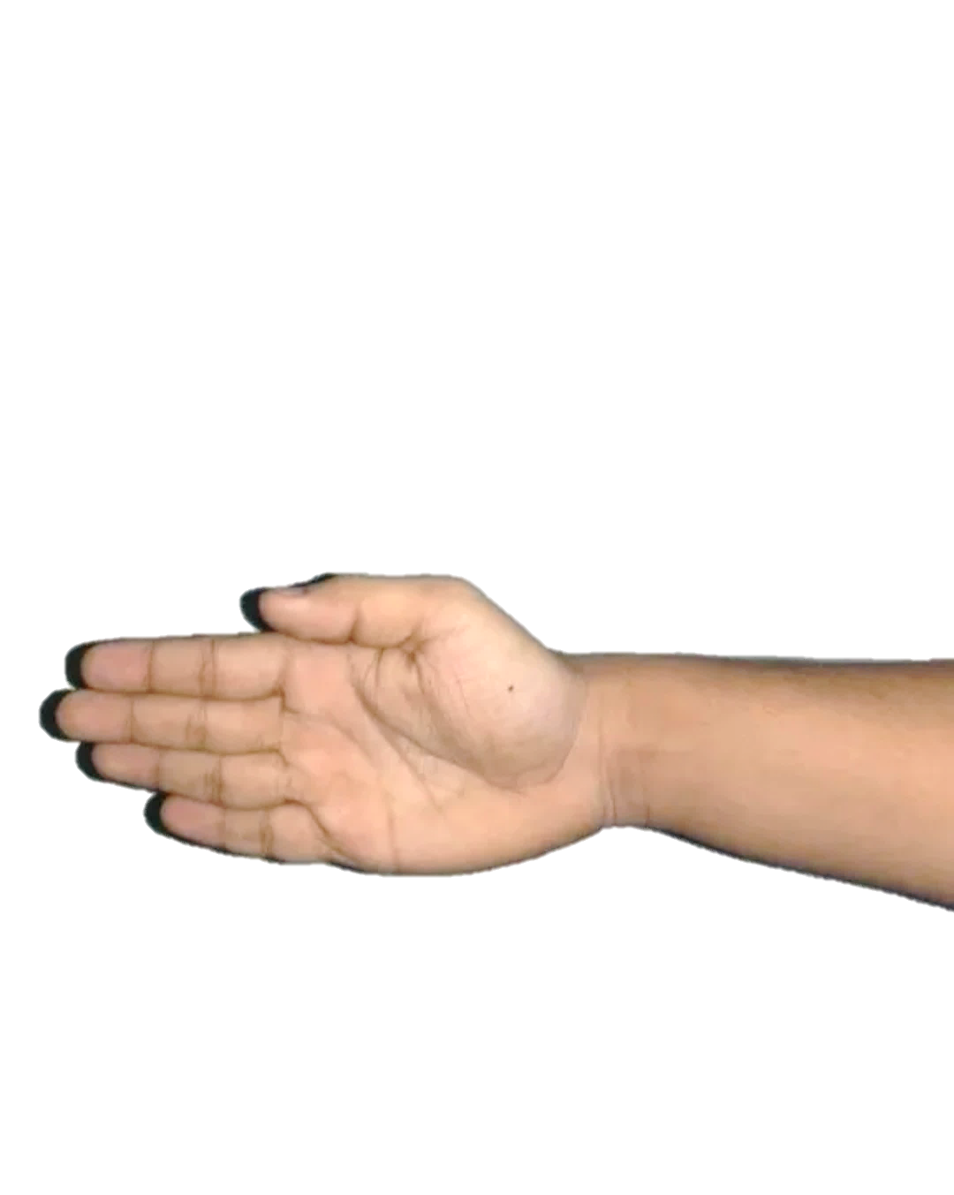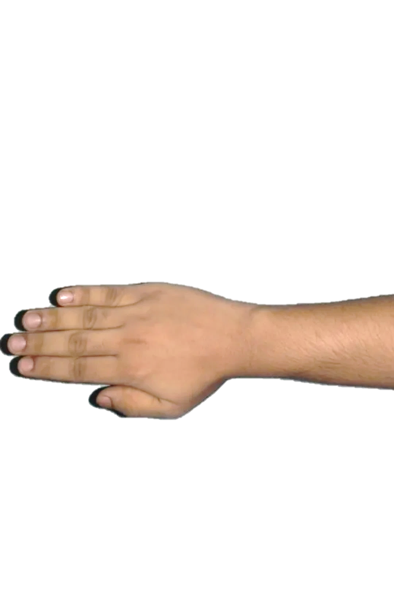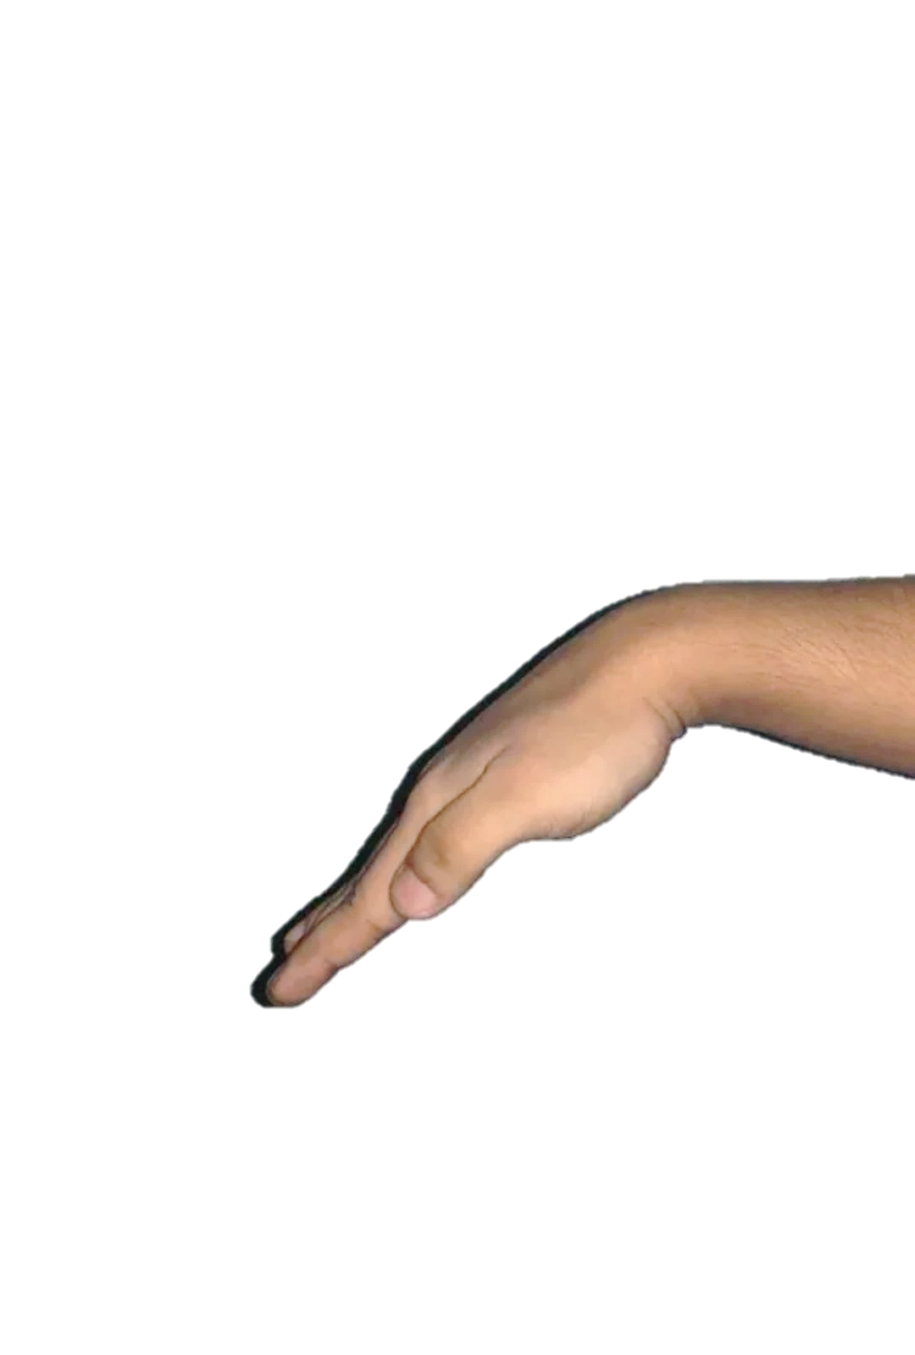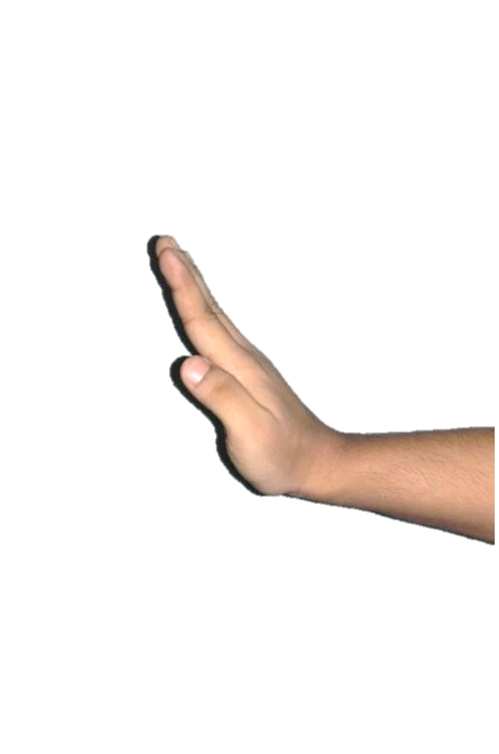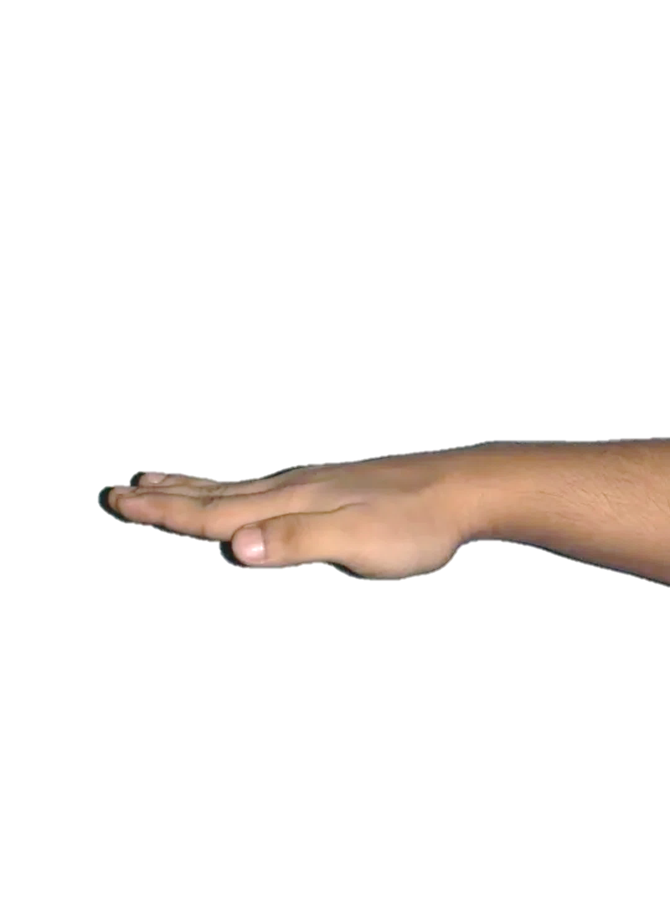

**Right**

**Forward**

**Backward**

**Stop**

**Left**

Figure 1: Hand Gesture Movements of Robot

* A Gesture is an action that has to convey a some piece of information or a data
* The Wireless Hand Gesture controlled Robot will function by a wearable hand glove from which the movements of the hand can be used as the input for the movement of the robot.
* In our project we will design a wearable Hand Glove which will contain the sensors mounted on it to capture the movement of the hand and convert the raw mechanical data into electrical form.

**CHAPTER-3**

**METHODOLOGY**

**3.1 Methodology**

“Development of hand gesture recognition sensor based on acceleration and gyroscope for controlling robotic car ” . In this project hand gesture sensor depends on accelerometer and gyroscope. An accelerometer sensor is a tool that measures the acceleration of any body or object in its instantaneous rest frame. Acceleration: rate at which velocity changes with time, in terms of both speed and direction. Gyroscopes: these are motion sensors that detect and measure the angular motion of an object. They measure the rate of rotation of an object around a particular axis: 1-axis, 2-axis, and 3-axis.Gyroscope is the sensor which is used to capture the position the operator hand when he is working in operated vehicle and it is attached with a hand. In case of communicating to the machine commands are being implemented use of hand gesture. Here the physical interaction has to be planned carefully as the system which interact normally and minimize obstacles. This project consists of physical interaction between the human and robotic car. It gives the best result after testing among the various factors. User-friendly, Easy to work.

**3.2 Analysis Of Existing System**

A lot of research work were carried out before and during this project The work consultation includes various standard review papers of robotics , arduino , Lilypad , research papers , YouTube ,internet as well as conversation with our guide. All data collected were used to verify whether the goal has been achieved and if not, the kind of corrective actions to introduce for the system development

**3.3 System Block Diagram**

**3.3.1 Transmitter Blocks**

MPU-6050 Sensor

Lilypad Arduino

HC-05 (Master) Transmitter

Gesture Control

Transmitter data

Figure 2: Transmitter Blocks

**3.3.2 Receiver Blocks**

L298N Motor Driver Module

Arduino UNO

HC-05(Slave) Receiver

Robot

Receiver data

Figure 3: Receiver Blocks

The Hand Gesture Control Robotic system designed in this project consist of both Hardware and Software parts in it. The Hardware Consists of system circuit i.e. Arduino and Lily pad, MPU-6050 Sensor Module, HC-05 Bluetooth Modules and L298N Motor driver Module while the Software consists of programming from Arduino IDE to Lily pad and Arduino and to build serial Communication between two HC-05 modules using AT Command Modes. This Block Diagram Consist of Transmitter and Receiver Blocks Where Transmitter has Accelerometer sensor responsible for gesture control of robotic car by receiving the data from the transmitter Bluetooth Module in the Receiver.

**3.4 System Flow Chart**

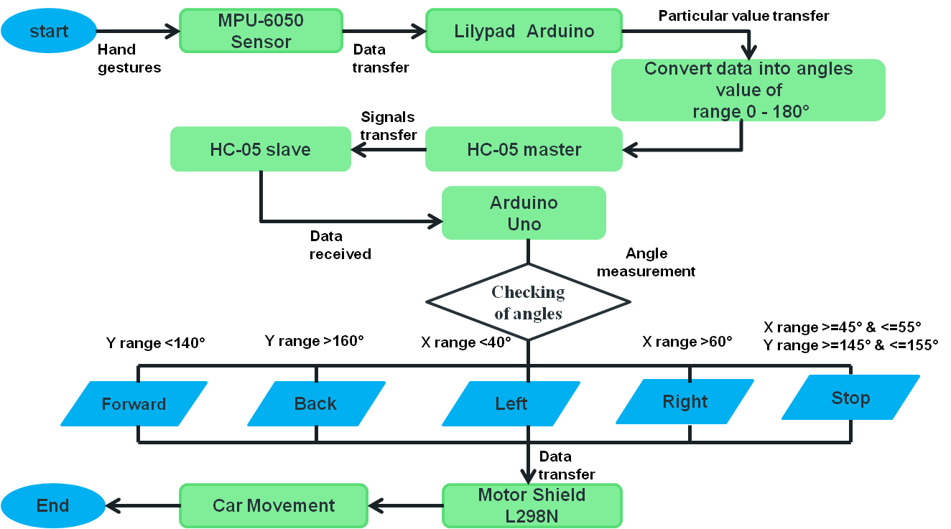

Figure 4: System Flow Chart

This is the System Flow Chart for the Hand Gesture Control Robotic car where it will start with sensing the Hand gesture movements of Robot using the MPU-6050 Module and it will transfer the data to the Lilypad Arduino and a particular data is transferred and converted into the degree of range 00 to 1800 to HC-05 Master i,e to the Transmitter Bluetooth Module .From this a data signal is transferred to the Receiver Bluetooth Module i,e HC-05 Slave .and then it will check for the particular angle measurement in the arduino by receiving the data from HC-05 . for the forward Movement it ranges Y range <140° , Backward Movement Y range >160 , Left X range <40° , Right X range > 60 and then for Stop is X range >=45° & < =55°Y range >=145° & <=155° The input data is transferred to the L298N Motor driver Module Therefore the Car Movement takes place by the rotating the wheels of the robot and hence the process flow ends

**3.5 Principle of Operation**

Gesture controlled robot works on the principle of accelerometer which records hand movements and sends that data to the comparator which assigns proper voltage levels to the recorded movements. Gesture Controlled Car is a robot which can be controlled by simple human gestures. The user just needs to wear a gesture device in which a sensor is included. The sensor will record the movement of hand in a specific direction which will result in the motion of the robot in the respective directions

**3.6 Circuit Diagrams and its Descriptions**

**3.6.1 Transmitter Circuit**

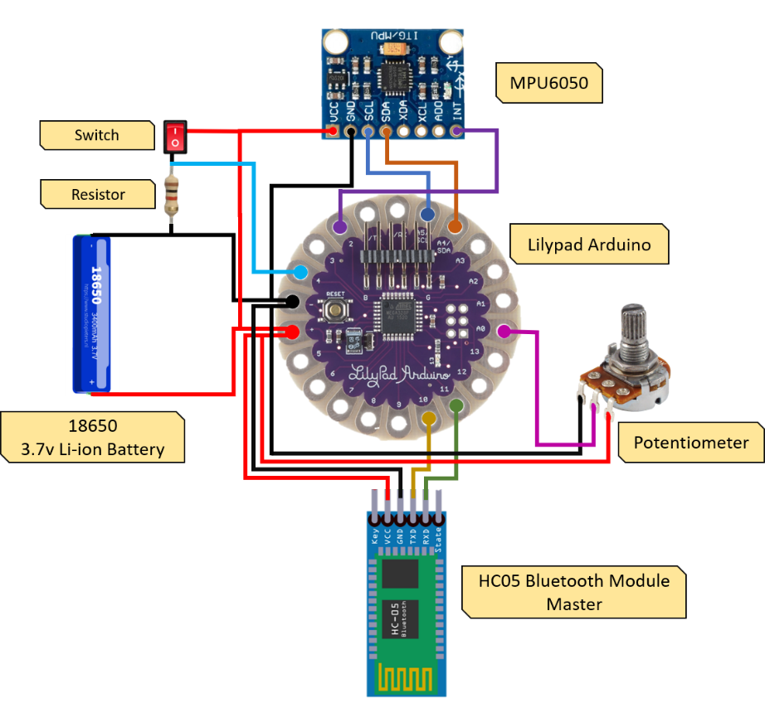

Figure 5: Transmitter Circuit

**3.6.2 Circuit Description of Transmitter Circuit**

In the Circuit Diagram shown in Figure 5 is the Transmitter Circuit which consists of MPU-6050 Module , Lilypad Arduino , HC-05 Bluetooth Module (Master) , and a power supply of 18650 Lithium ion Battery is given which is Connected as follows : The MPU-6050 and HC-05 (Master) the Vcc and Gnd pins are Connected to the Vcc and Gnd Pins of the Lilypad Arduino , the SCL and SDA Pins of the MPU-6050 is Connected to the A5(SCL) and A4(SDA) pin of the Lily pad . Interrupt pin to the digital pin 2 of Arduino. And Tx and Rx Pin of Bluetooth Module is Connected to the digital Pin 10 and 11 of Lilypad and a power Supply of 3.7V to 5v can be given. potentiometer is used to control the speed and and Push button to stop robotic car transmitter and receiver data transmission .This is the Transmitter Circuit Description of Hand Gesture Control Robotic Car which is Mounted or Placed on the hand to control the robot

**3.6.3 Receiver Circuit**

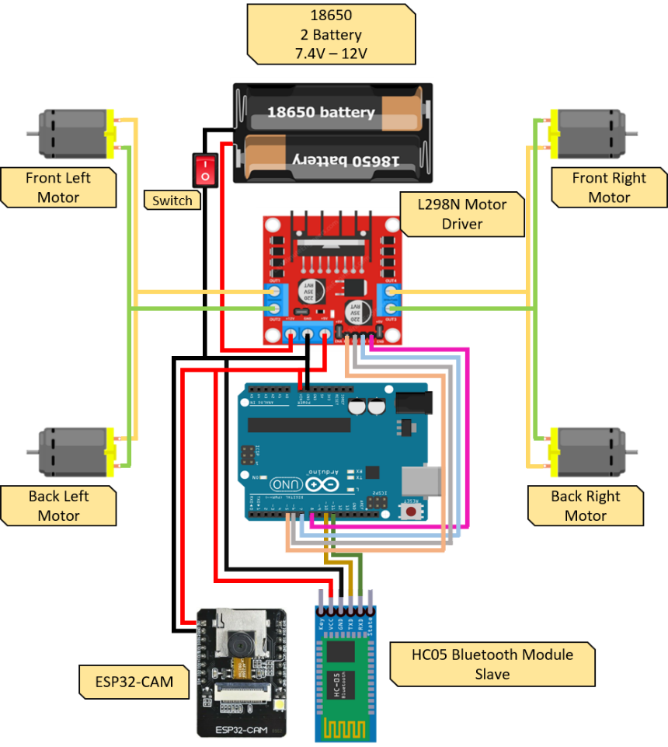

Figure 6: Receiver Circuit

**3.6.4 Circuit Description of Receiver Circuit**

In the Circuit diagram of Figure 6 is the Receiver Circuit where we have 4 BO DC Motor i,e Connected to the output pins of L298N Motor Driver Module. Vcc and Gnd of the Motor driver is connected to Arduino Uno and HC-05 Slave . The input pins of L298N is connected to the Digital pins of Arduino Uno and Tx and Rx of HC-05 Slave Module is Connected to the digital pin 10 and 11 of arduino and a Power Supply of 7.4 V to 12 V can be given this Receiver Circuit description of Hand Gesture Controlled Robotic Car.

**3.7 Description of components (Requirements**)

**3.7.1 Hardware**

**1 . Arduino Uno R3**

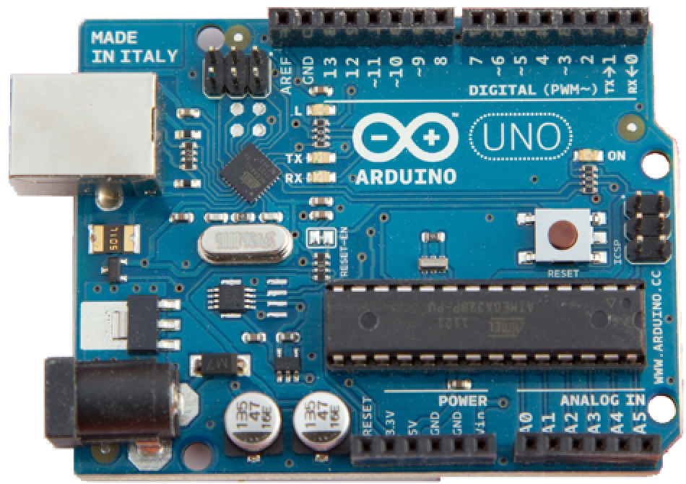

Figure 7 : Arduino Uno R3

Arduino UNO is a microcontroller board based on the ATmega328. It has 14 digital input/output pins 6 analog input pins, a USB Connection, an I2C bus and a reset button .It is an open source electronic prototyping board which can be programmed easily

**How to use Arduino Board:-**

The 14-digital input/output pins can be used as input or output pins by using pin mode(), digital read() and digital write() functions in arduino programming . Each pin operates at 5V and can provide or receive a maximum of 40mA current, and has an internal pull-up resistor of 20-50 K Ohms which are disconnected by default . Out of these 14 pins, some pins have specific functions as listed below:

**Communication using Arduino Board:**

Arduino can be used to communicate with a computer, another Arduino board or other micro controllers. The ATmega328P microcontroller provides UART TTL (5V) serial communication which can be done using digital pin 0 (Rx) and digital pin 1 (TX). An ATmega328 on the board channels this serial communication over USB and appears as a virtual com port to software on the computer. The Arduino software includes a serial monitor which allows simple textual data to be sent to and from the Arduino board. The Arduino software includes a Wire library to simplify use of the I2C bus.

**2. Lilypad Arduino**

The Lily Pad Arduino 328 Main Board is an Arduino-programmed microcontroller designed to be easily integrated into e-textiles and wearable project. It works on rechargeable batteries and allows easy connection with sensors and actuators developed for an easy integration in clothes and fabrics. It was developed by Leah Buechley and Spark fun Electronics . All the functions that is performed using Arduino Uno can be done in the Lily pad Arduino. It comes in a round shape unlike other Arduino boards so that it could fit easily in wearables.However, the ability of this board to be sewn down with the fabric or sensor through conductive thread puts it ahead and stands out of the boards available in the Arduino community.

* There are 22 wide open pin-holes, appear around the edge of the whole rounded shape that is mainly used for the connection with the fabric and sensor through a conductive thread.
* Out of these 22 pinholes, one is reserved for +5V, and one for ground.

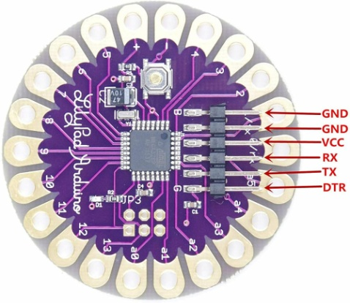

Figure 8 : Lilypad Arduino

**3. HC-05 Bluetooth Module**

HC-05 is a Bluetooth module which is designed for wireless serial communication This module is used in master or slave configuration.HC-05 has two operating modes , one is the data mode in which it can send and receive the data from other and another is AT command mode where default device settings can be changed . Bluetooth Communication is a 2.4GHz frequency based RF Communication with a range of approximately 10 meters. It is one of the most popular and most frequently used low range communication for data transfer, audio systems, hands free, computer peripherals etc. HC-05 Bluetooth Module is a simple Wireless Communication device based on the Bluetooth Protocol.

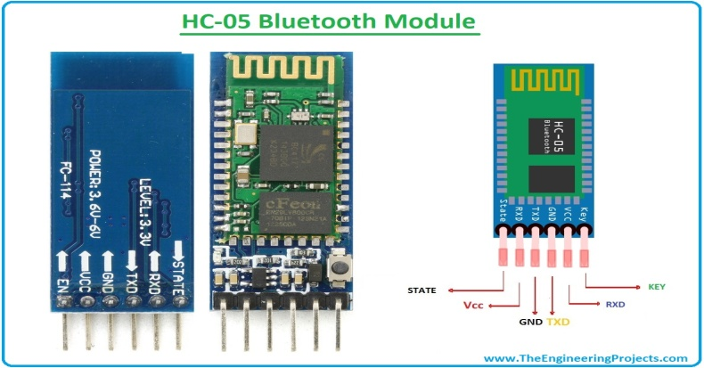

Figure 9 : HC-05 Bluetooth Module

**4. L298N Motor Driver Module**

The L298N Motor Driver module consists of an L298 Motor Driver IC, 78M05 Voltage Regulator, resistors, capacitor, Power LED, 5V jumper in an integrated circuit.78M05 Voltage regulator will be enabled only when the jumper is placed. When the power supply is less than or equal to 12V, then the internal circuitry will be powered by the voltage regulator and the 5V pin can be used as an output pin to power the microcontroller. The jumper should not be placed when the power supply is greater than 12V and separate 5V should be given through 5V terminal to power the internal circuitry. ENA & ENB pins are speed control pins for Motor A and Motor B while IN1& IN2 and IN3 & IN4 are direction control pins for Motor A and Motor B.

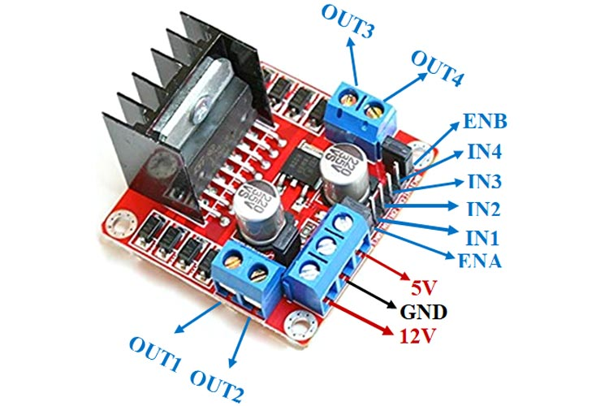

Figure 10 : L298N Motor Driver Module

**5. MPU6050 Module**

MPU6050 is a Micro Electro-mechanical system (MEMS), it consists of three-axis accelerometer and three-axis gyroscope. It helps us to measure velocity, orientation, acceleration, displacement and other motion related Parameters of a system or an object. MPU6050 consists of a 16-bit analog to digital converter hardware. Due to this feature, it captures three-dimension motion at the same time. This module has some famous features which are easily accessible, due to its easy availability it can be used with any type of microcontroller like Arduino

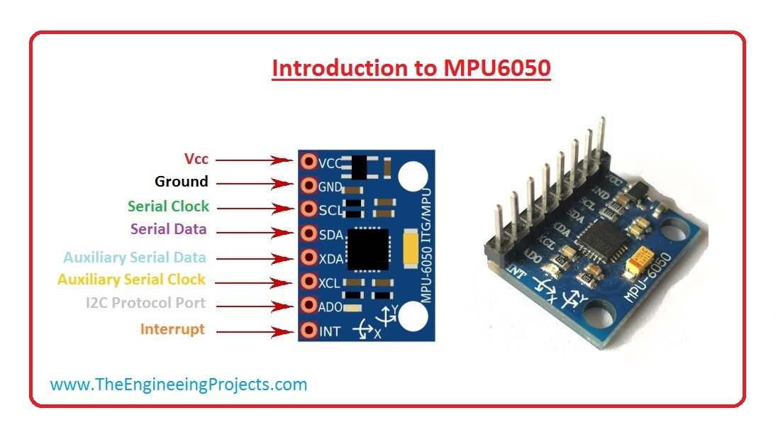

Figure 11 : MPU6050 Module

The Internal Micro Structure for the MPU-6050 Module is given below in Which Mass is attached to the springs where it is confined to move in one direction. When an acceleration is applied in a particular direction the mass will move and it will change the capacitance between the fixed plates of the capacitor. This Process allows the MPU-6050 module to sense and to send the Particular acceleration value .

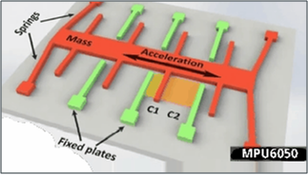

Figure 12: Internal Micro Structure for the MPU – 6050 Sensor

**6. Other Hardware components**

**6.1 ESP32 Cam Module with OV2 640 Camera**

The ESP32 CAM Wi-Fi Module Bluetooth with OV2640 Camera Module 2MP For Face Recognition has a very competitive small-size camera module that can operate independently as a minimum system with a footprint of only 40 x 27 mm; a deep sleep current of up to 6mA and is widely used in various IoT and Embedded applications. It is suitable for home smart devices, industrial wireless control, wireless monitoring, and other applications .This module adopts a DIP package and can be directly inserted into the backplane to realize rapid production of products, providing customers with high-reliability connection mode, which is convenient for application in various hardware terminals.

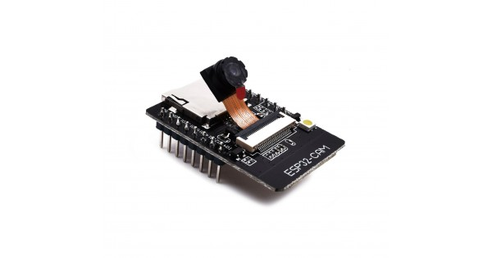

Figure 13: ESP32 Cam Module with OV2640 Camera

**6.2 Potentiometer**

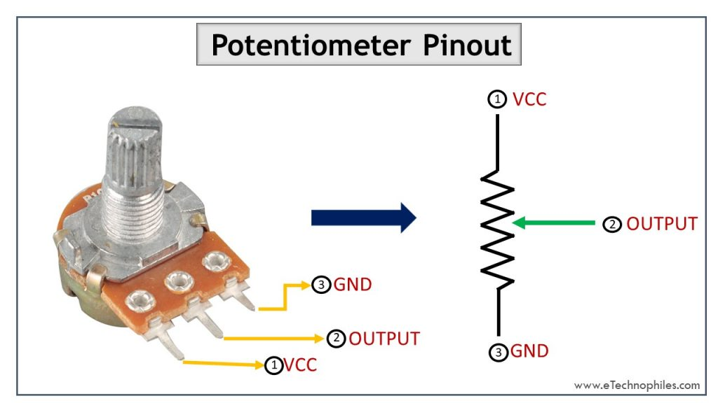

Figure 14: Potentiometer

A potentiometer is a manually adjustable variable resistor with 3 terminals. Two of the terminals are connected to the opposite ends of a resistive element, and the third terminal connects to a sliding contact, called a wiper, moving over the resistive element. The potentiometer essentially functions as a variable resistance divider. The resistive element can be seen as two resistors in series (the total potentiometer resistance), where the wiper position determines the resistance ratio of the first resistor to the second resistor. If a reference voltage is applied across the end terminals, the position of the wiper determines the output voltage of the potentiometer. A potentiometer is also commonly known as a pot meter or pot The most common form of pot meter is the single turn rotary pot meter. This type of pot is often used in audio volume control and Speed Control as well as many other applications.

**7. Car Chassis**

This is a longer version of 4 WD double-layer smart car chassis. It comes with the four pairs of Geared BO DC Motors and Wheels. Bo motor (Battery Operated) lightweight DC geared motor which gives good torque and rpm at lower voltages. Here you can get BO DC Motor with varying rated speed. This motor can run at approximately 200 rpm when driven by a single Li-Ion cell. Great for battery operated lightweight robot

Features

* Very handy and simple in assembling/disassembling.
* Strong components to withstand extreme terrain conditions.
* Double-layer structure, much of mounting holes, enough space
* Easy to install a variety of control panels, sensors
* Educational toys, Ideal for the DIY platform with attractive design

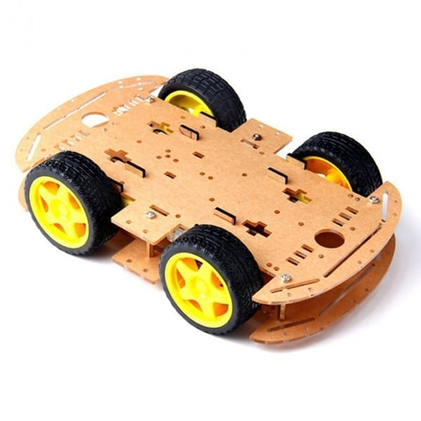 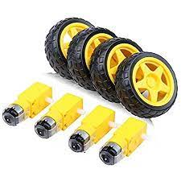

Figure 15: Car Chassis Figure 16: BO DC Motors

**8. Lithium Ion Batteries**

Li-ion batteries are a popular choice of rechargeable battery for use in many applications like portable electronics, automobiles as well as stationary applications for providing uninterruptable power supply. State of Charge (SoC) and State of Health (SoH) are important metrics of a Li-ion battery that can help in both battery prognostics and diagnostics for ensuring high reliability and prolonged lifetime .They are recharged using TP4056 Li-Ion Battery charging Module.

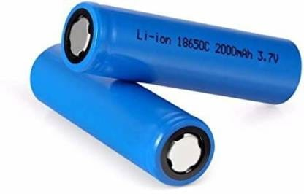

Figure 17: Lithium Ion Batteries

**9. Jumper Wires**

Jumper wire are extremely handy component to have on hand, especially when prototyping. Jumper wire is simply wires that have connector pins at each end, allowing them to be used to connect two points to each other without soldering . Jumper wires are typically used with breadboards and other prototyping tools in order to make it easy to change a circuit as needed. Jumper wire typically come in three versions; male-to-male, male-to-female, female-to-female. The difference between each is in the end point of the wire. Male ends have a pin protruding and can plug into things, while female ends do not and are used to plug things into .When connecting two ports on a breadboard, a male-to-male wire is we’ll need.

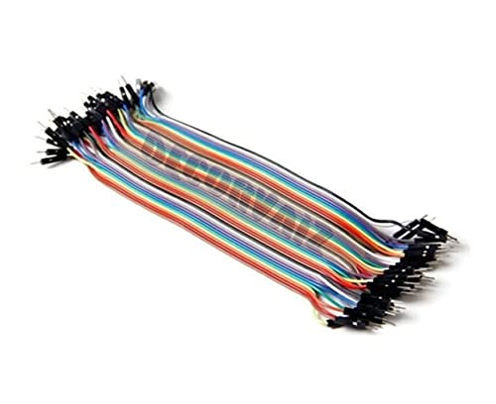

Figure 18: Jumper Wires

**3.7.2 Software:**

**1. Arduino IDE**

* The open source Arduino IDE software makes it easy to use and upload the code to the boards such as Arduino UNO, ESP32, and Node MCU etc.
* The Arduino IDE supports the languages C and C++ using special rules of code structuring.



Figure 19: Arduino IDE Logo

**CHAPTER-4**

**THE SYSTEM IMPLEMENTATION AND**

**SOFTWARE DEVELOPMENT**

**4.1 Working of system**

* The whole project is divided into two sections one is the transmitter section and the other is the receiver section..
* We place the transmitter in our hand. The gesture controlled robot makes movements according to the hand gestures that are user-defined in the program.
* The Transmitter and Receiver Pair Configuration of Robot is done using the HC-05 as Master and Slave
* To Configure and Pair HC-05 Module as Master and Slave we use the AT Command Modes
* The Circuit Connection to Pair HC-05 Module is given below

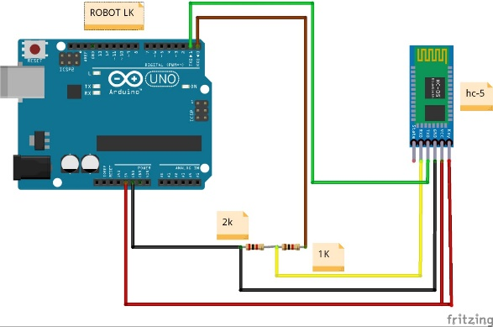

Figure 20 : Circuit diagram for HC-05 Master and Slave

* To give AT commands, open your Serial Monitor. For about 1 second, a sentence saying "Enter AT commands:" will pop up. But before that, remember to change "No Line Ending" to "Both NL & CR" and also fix the baud rate at 9600.

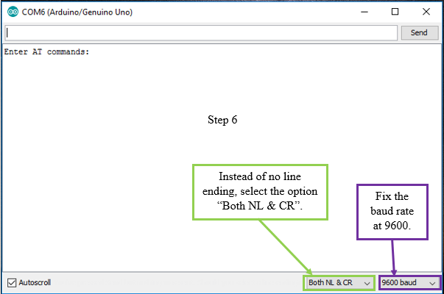

Figure 21 : AT Command Mode Serial Monitor

* To see whether everything is okay or not, enter "AT" and send. An "OK" will pop up on the Serial Monitor and this implies that no problems occur.
* **Slave Configuration:**
* The required AT commands to set the configuration
* AT+RMAAD (To clear any paired devices)
* AT+ROLE=0 (To set it as slave)
* AT+ADDR (To get the address of this HC-05, remember to jot the address down as it will be used during master configuration)
* AT+UART=38400,0,0 (To fix the baud rate at 38400)

If the commands entered are replied with "OK" then it indicates that the settings mentioned have been customized.

* **Master Configuration:**
* The required AT commands to set the configuration:
* AT+RMAAD (To clear any paired devices)
* AT+ROLE=1 (To set it as master)
* AT+CMODE=0 (To connect the module to the specified Bluetooth address and this Bluetooth address can be specified by the binding command)
* AT+BIND=xxxx,xx,xxxxxx (Now, type AT+BIND=98d3,34,906554 obviously with your respective address to the slave. Note the commas instead of colons given by the slave module.
* AT+UART=38400,0,0 (To fix the baud rate at 38400)

If the commands entered are replied with "OK" then it indicates that the settings mentioned have been customized.

Using the above steps we can configure transmitter and receiver HC-05 Bluetooth modules.

* The hardware implementation of Transmitter and Receiver circuits are made as shown in the fig.5 and fig.6
* We upload codes to the Lilypad Arduino in Transmitter circuit and Arduino Uno in the Receiver circuit.
* We have designed a wearable Hand Glove which will contain the sensors mounted on it to capture the movement of the hand and convert the raw mechanical data into electrical form.
* When hand is tilted in front side, Transmitter unit transmits ‘F’ character to the Receiver of the robot. Then robot starts to move in forward direction and continues moving forward until next command is given.
* When hand is tilted in backward side, Transmitter unit transmits ‘B’ character to the Receiver of the robot. Then robot starts to move in backward direction and continues moving forward until next command is given.
* When hand is tilted in Right side, Transmitter unit transmits ‘R’ character to the Receiver of the robot. Then robot starts to turn in Right direction and continues to turn Right until next command is given.
* When hand is tilted in Left side, Transmitter unit transmits ‘L’ character to the Receiver of the robot. Then robot starts to turn in Left direction and continues to turn Left until next command is given.
* And for stopping robot hand is kept stable, Transmitter unit transmits ‘S’ character to the Receiver of the robot. This is the working of hand gesture control robotic system.

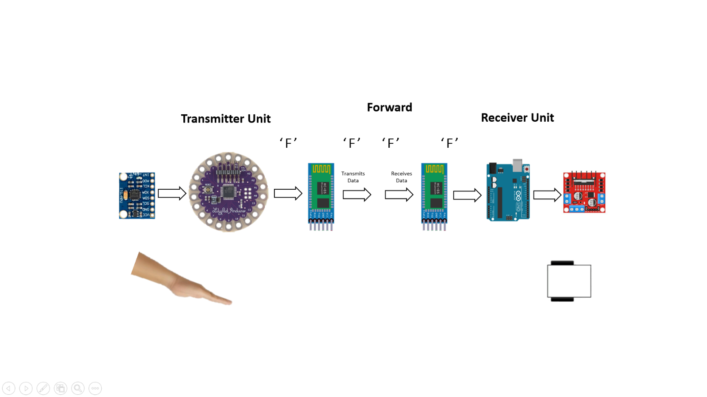

Figure 22 : Transmitter and Receiver Unit Working

* Additionally we have added Potentiometer in the Transmitter circuit to control the speed of the robot.
* Also, we have used ESP32-CAM in the Receiver circuit for wireless video monitoring of where the robot goes.

**Algorithm:**

Step 1: Start

Step 2: Hand gestures are taken as input.

Step 3: MPU6050 senses the hand gesture movements.

Step 4: Data is transferred from MPU6050 to Lilypad Arduino.

Step 5: Lilypad Arduino converts the data into particular angle of range 00 to 1800 in both X and Y axis.

Step 6: Converted angle is transferred as data to the HC-05 Transmitter Bluetooth Module (Master).

* If y range < 1400 transmitter will send the ‘F’ character as data.
* If y range >1600 transmitter will send the ‘B’ character as data.
* If x range < 400 transmitter will send the ‘L’ character as data.
* If x range > 600 transmitter will send the ‘R’ character as data.
* If x range >=45° & <=55°, y range >=145° & <=155**°**  transmitter will send the ‘S’ character as data.

Step 6: HC-05 Master transfers these character data signals to the HC-05 Receiver Bluetooth Module (Slave).

Step 7: Slave Module then transfers the complete data to the Arduino Uno.

Step 8: Arduino Uno will check for the particular character data and transfers the control to motor driver.

Step 9 : Based on these data the movements is made by the L298N motor driver

* If the received character is ‘F’ then the Robot moves in the Forward direction.
* If the received character is ‘B’ then the Robot moves in the Backward direction.
* If the received character is ‘L’ then the Robot moves in the Left direction
* If the received character is ‘R’ then the Robot moves in the Right direction
* If the received character is ‘S’ then the Robot Stops.

Step 10: End

**CHAPTER – 5 : OUTCOMES**

**5.1 Work Done**

* Detailed research was done on Hand Gesture Control Robotic system.
* Code execution for Transmitter and Receiver of Gesture Control Robot was done in Arduino IDE software.
* Bluetooth Configurations as of Master (Transmitter) and Slave (Receiver) is done Successfully.
* ESP32 Cam Wi-Fi network is built and seen the car where it goes through camera as Surveillance Robotic Car
* Speed of the car can be increased or decreased using the Potentiometer according to user requirement.
* Push Button and Switches are used additionally in Transmitter and Receiver Circuit to Power on and off the Robotic car .
* Hardware implementation of Hand Gesture Controlled Robotic Car was completed and tested.

**5.2 Future Scope**

* The future of gesture controlled technology is very promising.
* Video gaming will become more interesting and creative with the help of hand gesture control technology
* Discovery people for their studies on animals by playing different sounds & for their exploration.
* GPRS and GPS modules can be added for place location . A Video Camera can be added for Live streaming.
* It can also be used for Traffic Monitoring
* We can add bomb and metal detectors and can send to place, harmful for a person to go.
* Gesture controlled robots has a potential in growing market all around the world

**5.3 Limitations**

* If power supply fails system won’t work
* Failure of device / components may have direct consequences, fatal accidents can occur.
* On the user’s side, these problems are to learn, to remember and to accurately execute gestures.
* The HC-05 Bluetooth Module has a limited range of operation (around 10 – 15 meters) . This problem can be solved by using the RF Module or Wi-Fi Module.
  1. **Results**

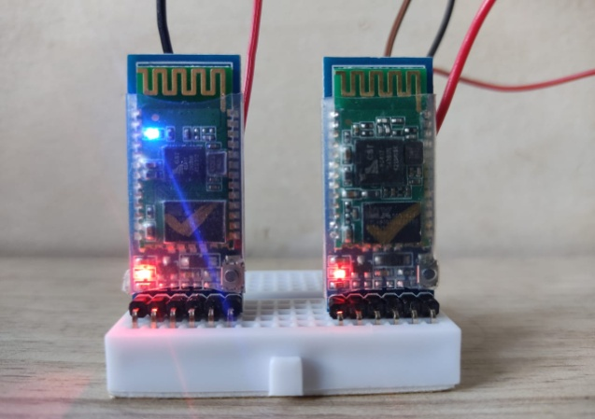

Figure 23: HC-05 Bluetooth Pair Configuration as Master and Slave Set up

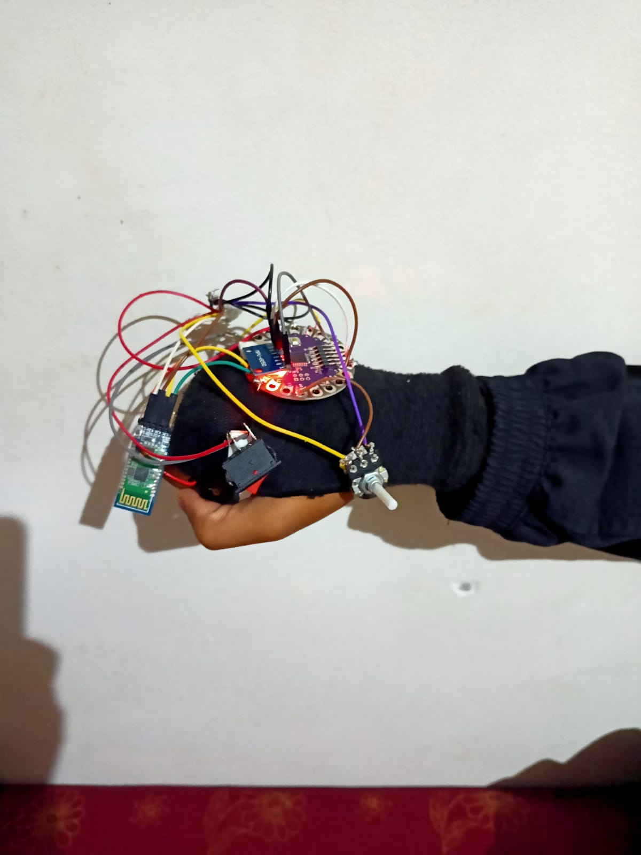

Figure 24: Transmitter Hand Glove

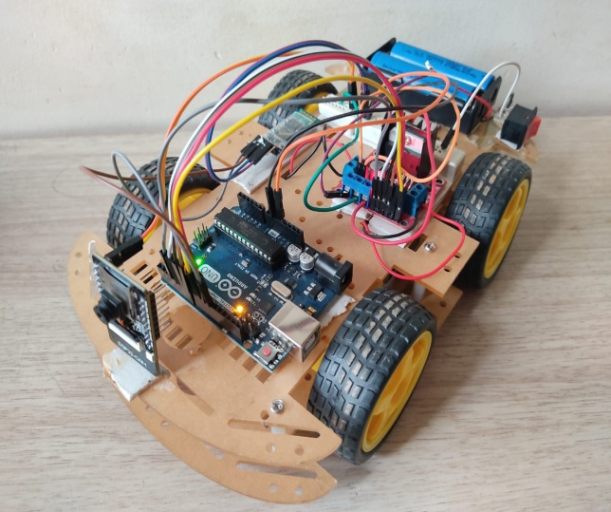

Figure 25: Receiver Robot

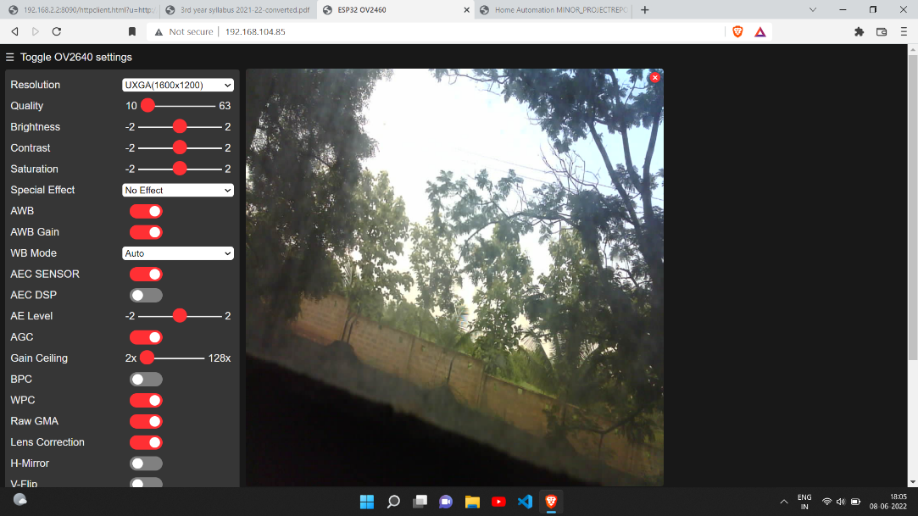

Figure 26: ESP32-Cam Monitor interface

* 1. **Cost Analysis**

|  |  |  |  |
| --- | --- | --- | --- |
| **Sl. No.** | **Components** | **Quantity** | **Cost** |
| 1 | Car chassis | 1 | 700 |
| 2 | Arduino Uno | 1 | 499 |
| 3 | Lilypad Arduino | 1 | 261 |
| 4 | HC05 Bluetooth Module | 2 | 416 |
| 5 | MPU6050 | 1 | 116 |
| 6 | Battery Holder | 1 | 24 |
| 7 | Lithium ion Battery | 3 | 174 |
| 8 | TP4056 Battery charging module | 1 | 23 |
| 9 | Potentiometer | 1 | 12 |
| 10 | ESP32 Cam | 1 | 490 |
| 11 | L298N Motor Driver Module | 1 | 125 |
| 12 | Switches | 2 | 20 |
| 13 | Jumper wires | 50 | 80 |

|  |  |
| --- | --- |
| Total Cost | ₹2940 |

**5.6 Conclusion**

We have successfully implemented a hand-gesture-based interface for navigating a car-robot with some additional features such as control of speed and Esp-32 cam video monitoring of the robotic car . A user can control a car-robot directly by using his or her hand trajectories. In this project accelerometer based hand gesture-controlled robot works based on accelerometer outputs, which correspond to hand movements and sends that data to the lily pad arduino which assigns specific value to the movements. This information is transferred through the HC-05 Bluetooth Module (Master) to the receiver of robot. On the other end, the information is received wirelessly via HC-05 Bluetooth Module (slave). These decisions are sent to the motor driver, which triggers the motors in specific configurations to make the robot move in different directions. Thus this proposed system will be helpful in various applications and will surely fulfil in all aspects and provide benefits to society and the people

**5.7 References**

1. Ch. Prem Kumar and Salumari Madhu, “Gesture Control Robot with Arduino,” IOP Conference Series: Materials Science and Engineering, vol. 455, conference 1, 2018.
2. S. Siddharth Rautaray, and Anupam Agrawal, “Real Time Gesture Recognition System for Interaction in Dynamic Environment,” in Procedia Technology, vol. 4, pp. 595-599, 2012
3. Dinesh Kumar Bhusare, Shilpa Karale, Pooja Pawar and R. K. Sarawale, “Hand Gesture by Using Robotic Car Control,” in International Journal of Advanced Research in Computer Engineering & Technology, vol. 4, no. 3, pp. 830-833, March 2015
4. Vijaya Laxmi, “Image Processing Based Hand Gesture Controlled Robot On Raspberry Pi,” in International Journal of Engineering & Science Research, vol. 6, no. 3, pp. 49-54, March 2016.